### **Project Design Phase-II**

### **Data Flow Diagram & User Stories**

**Date**: April 14, 2025

**Team ID**: SWTID1742745633

**Project Name**: ViewVoyage

**Maximum Marks**: 4 Marks

**ViewVoyage – Data Flow Diagrams**

**Level-0 DFD Description**

**Actors:**

* **User:** A viewer who watches, likes, comments, and saves videos.
* **Admin:** Manages platform activities and users.
* **Process Video:** Handles video uploads, playback requests, and downloads.
* **Manage Interactions:** Processes likes, comments, and user-specific data like “Your List.”
* **Authentication:** Handles login and registration.
* **Admin Actions:** Deletes users or manages reports.
* **Video Data:** Stores video metadata, URLs, and thumbnails.
* **User Data:** Stores user credentials, lists, liked videos.
* **Comment Data:** Stores comments linked to videos and users.

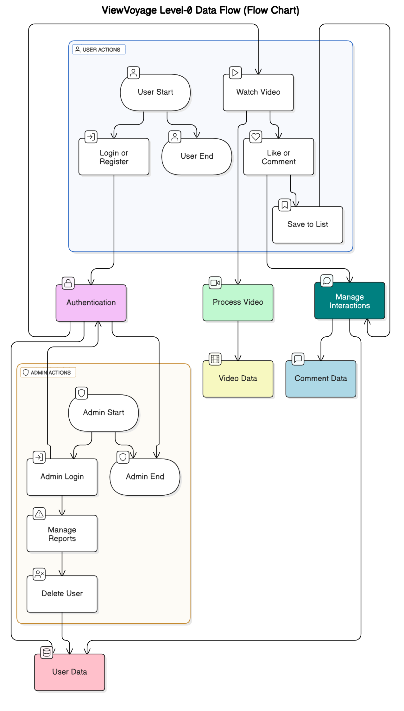  
  
  
**Level-1 DFD Processes**

|  |  |
| --- | --- |
| **Process** | **Function** |
| **User Interface (UI)** | Manages all user interactions including home, video, search, and dashboard |
| **Authentication** | Handles secure login and registration using JWT and hashed passwords |
| **Video Processor** | Fetches videos, plays them, and enables download or sharing |
| **Interaction Manager** | Manages likes, comments, and saving videos to user-specific lists |
| **Admin Controller** | Enables admin functions like deleting users or moderating reports |

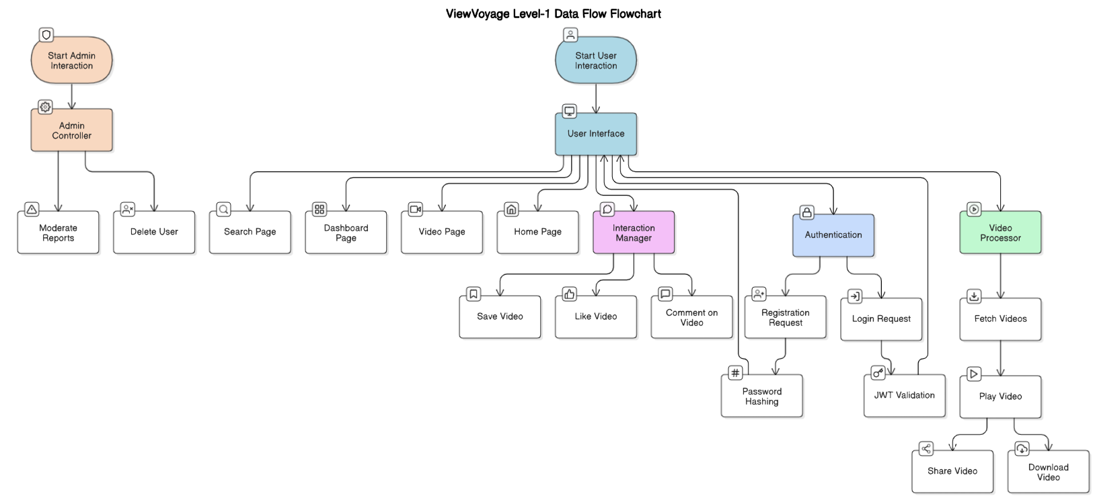

**ViewVoyage – User Stories**

|  |  |  |  |  |  |  |
| --- | --- | --- | --- | --- | --- | --- |
| **User Type** | **Epic (Functional Area)** | **Story ID** | **User Story** | **Acceptance Criteria** | **Priority** | **Sprint** |
| User | User Management | VW-US1 | As a user, I want to register using my email and password | I can register and receive access to the homepage | High | Sprint 1 |
| User | User Management | VW-US2 | As a user, I want to log in securely | I can log in and access features like Liked Videos | High | Sprint 1 |
| User | Video Management | VW-US3 | As a user, I want to browse and search videos | I can view videos and filter them by title | High | Sprint 1 |
| User | Video Detail + Interaction | VW-US4 | As a user, I want to like and comment on videos | My likes are saved and comments show up instantly | High | Sprint 2 |
| User | Video Playlist (Your List) | VW-US5 | As a user, I want to save videos to a personal list | Saved videos are visible under "Your List" | Medium | Sprint 2 |
| User | Video Detail | VW-US6 | As a user, I want to download and share videos easily | Download button triggers download; share shows video link | Medium | Sprint 3 |
| Admin | Admin Management | VW-US7 | As an admin, I want to view and manage users | Admin dashboard shows user list with action buttons | High | Sprint 3 |
| Admin | Admin Moderation | VW-US8 | As an admin, I want to delete users if necessary | Deleted user is removed from the database and UI | High | Sprint 3 |